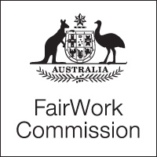

Notice of Listing

Title of Matter: | Annual wage review
Section: | s.285 - Annual wage review
Subject: | Annual Wage Review 2020-21 Decision
Matter Number: | C2021/1

Listing Details:
The above matter is listed for Decision at:
3:30pm (AEST)
Wednesday 16 June 2021
To be broadcast online only

NOTE:

The Decision will be broadcast on the Fair Work Commission website.

To watch the broadcast, please use the link that will be available on the Commission’s home page.

Inquiries:
All inquiries relating to this notice are to be directed to chambers.ross.j@fwc.gov.au
Fair Work Commission, 16 June 2021

