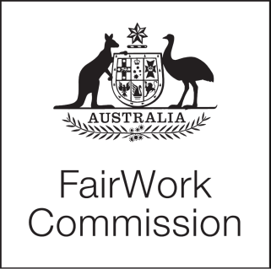
[2021] FWC 6381

STATEMENT
Fair Work Act 2009
s.285—Annual wage reviews to be conducted

Annual Wage Review 2021–22
(C2022/1)
JUSTICE ROSS, PRESIDENT | MELBOURNE 18 NOVEMBER 2021

RESEARCH PROGRAM

- On 18 October 2021, a Statement providing a draft research program for the Annual Wage Review 2021–22 was published for comment. Three submissions were received from the Australian Council of Trade Unions, Australian Industry Group and the United Workers Union and published on the Fair Work Commission website.

- No submission sought to change the research program. Each submission provided suggestions to the conduct of the research and these suggestions will be considered.

- The draft research program, as published on 18 October 2021, is now confirmed.

PRESIDENT

Printed by authority of the Commonwealth Government Printer

<PR735915>

