Annual Wage Review 2021–22 Questions on notice

14 April 2022
All interested parties are invited to comment.

Table of contents

Economic and labour market considerations 2
Question to the Australian Government 2
Question to the ACTU 2
Question to MGA 3
Question to NFF 3
Relative living standards and the needs of the low paid 4
Question to all parties 4
Exceptional circumstances 4
Question to ACCI 4

Economic and labour market considerations

Question to the Australian Government
Section 5 of the Australian Government’s initial submission presents evidence on the importance of small business to total employment. Has the Australian Government examined whether the significance of small business to employment over time has declined, and if so, what factors have been driving this trend?
Other parties are invited to comment on this.

Question to the ACTU
The ACTU initial submission stated that ‘[t]he reduction in employment seen in 2021 was not only smaller but more gradual at the aggregate level than seen in 2020, however the rebound appeared even more swift. Given that the accompanying chart (Figure 4, reproduced below) shows that the monthly percentage change in employment across August, September and October 2021 were below that of the corresponding months in 2020, how can employment falls during this period be characterised as smaller?
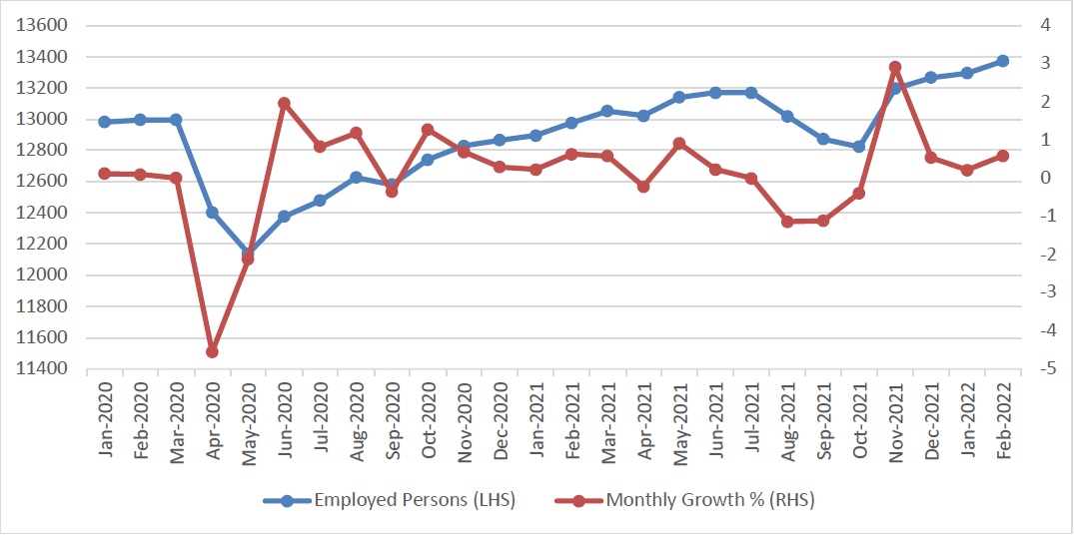
Other parties are invited to comment on this.

Question to MGA
Chart 6.1 in the Statistical report shows that the underemployment rate is the lowest it has been in more than 10 years. Several submissions noted the recent relatively low underemployment rate, particularly following the removal of restrictions due to the spread of COVID-19.
Master Grocers Australia (MGA) submitted that the current economic downturn and the effects of previous annual wage review decisions have led to an increase in underemployment among independent retailers.
Can MGA provide evidence or data showing an increase in underemployment in the retail industry?
Other parties are invited to comment on this.

Question to NFF
The NFF initial submission places emphasis on the slim margins farmers work with. This seems to contrast with the profit margins data produced by the Australian Bureau of Statistics (ABS) and reported in the Commission’s Statistical Report (Table 3.5). Are the profit margin estimates produced by the ABS a fair reflection of profitability in the agriculture sector, and if not why not?
Other parties are invited to comment on this.

Relative living standards and the needs of the low paid

Question to all parties
An information note describing the relevant announcements from the 2022–23 Budget has been prepared by staff of the Commission and published on the Commission’s website. Parties are invited to comment on these measures.

Exceptional circumstances

Question to ACCI
In its initial submission, ACCI stated that:
There is a clear case for exceptional circumstances for customer facing service industries, in the accommodation and food services, arts and recreation and retail sectors, as well as tourism related businesses in the transport sector. It could be argued that the current situation for these industries and the outlook is far worse than it was at the time the Panel made its decision in 2021.
What evidence or data can be provided to show that the current situation for these industries is worse than at the time of the Annual Wage Review 2020–21?
Other parties are invited to comment on this.

ACTU initial submission, 1 April 2022, at para. 21.
ACTU initial submission, 1 April 2022, at para. 35; Ai Group initial submission, 1 April 2022, at p. 16; NFF initial submission, 1 April 2022, at p. 8.
MGA initial submission, 1 April 2022, at para. 20.
NFF initial submission, 1 April 2022, at p. 11.
ACCI initial submission, 1 April 2022, at para. 41.

