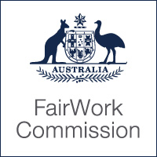
Thursday, 9 May 2019
Lisa Zhang
lisaz@aol.com.au
Dear Lisa Zhang

Your application fee has been waived
Case name | Zhang v General Things Pty Ltd
Case number | UD2019-123
Subject | Application for Unfair Dismissal Remedy
We have reviewed your request to have your application fee waived. We accept that you may suffer serious hardship if you had to pay the fee.
You don’t have to pay the fee.
If you have any questions about this letter, please call us on 1300 799 675 or email enquiries@fwc.gov.au.
Yours sincerely
Fair Work Commission

