Annual Wage Review 2013-14: Questions for final consultations
  - Question to CCIQ and National Farmers’ Federation (NFF)
To what extent have the recent rains in parts of New South Wales and Queensland ameliorated the effects of the drought upon businesses and their employee in those regions?

Recent rain in New South Wales and Queensland has been scattered and although many southern regions have received much needed Autumn rain, there are still many areas that have received little or no rain and are in severe drought. The current drought has been building for a few years, compounded by the hottest year on record across Australia in 2013 and many regions receiving record low rainfall. Two years without a wet season across many parts of Northern Australia is difficult for many farmers still recovering financially from the suspension of live cattle exports to Indonesia.

Queensland’s continued dry conditions are reflected in 38 entire local government areas and four part local government areas that are currently drought declared. There are also 53 current Individually Droughted Property (IDP) declarations in an additional nine Queensland local government areas. In New South Wales, twenty-seven local government areas and the far west Unincorporated Area are currently eligible for state government drought assistance.

According to the Department of Agriculture’s Weekly Australian Climate, Water and Agricultural Update, “despite widespread rainfall during April, long-term rainfall deficiencies persist in some regions, particularly in parts of central Queensland. The 19-month rainfall deficiency map for 1 October 2012 to 31 April 2014 shows severely deficient rainfall across large areas of Queensland, and smaller areas in northern New South Wales, northern South Australia, Western Australia and the Northern Territory.”

Even in areas that have received recent rain, farm incomes will not return until crops are harvested or the next generation of animals are sold. During drought situations, farmers spend much of their time caring for animals, providing feed and water that is not available due to the lack of rain. This is in addition to all the regular animal husbandry and farm maintenance tasks that still need to be undertaken on-farm. Often during drought conditions farmers will be busier than ever, with the days made even longer by hot, dry weather.

Many areas did not sow a crop last year or did and it failed. Some of these areas have still had insufficient rain to sow this year. It can easily take 12 months of reasonable or average rainfall before a recovery can occur.

See also the May drought statement issued by the Bureau of Meteorology at Attachment A.

10.1 Question to all parties

Few submissions directly addressed the variation of piece rates, though the ACTU supported a flow on of any minimum wage increase awarded as part of this Review to piece rates. The Panel invites the parties to consider and comment on how piece rates should be considered in this Review.

The NFF supports a flow on of any minimum wage increase to piece rates under the Pastoral Award 2010 and the Horticulture Award 2010. This should be done in the same manner as in previous years; in the Pastoral Award 2010 this means applying any increase awarded to the minimum rate (before loadings and allowances) from which the piece work rate is calculated.

May drought statement – Bureau of Meteorology Attachment A
Issued on 7 May 2014 by the National Climate Centre

Rainfall deficiencies remain in Queensland and northeastern New South Wales
A slow-moving trough linking to copious tropical moisture meant that April rainfall was above average over a broad band from northern Western Australia down through South Australia into western New South Wales and Victoria. Above-average rainfall largely missed areas of rainfall deficiencies in Queensland and northeastern New South Wales. Large parts of central and southern Queensland received average rainfall with small areas of below average rainfall, mostly recorded around southeast Queensland and northeastern New South Wales. Rainfall received in April has had little impact on the areas of rainfall deficiencies reported in the April Drought Statement.
Rainfall for the northern wet season (October to April) was mostly above average to very much above average over the western half of the country, except for southwest Western Australia where rainfall was very much below average. For the eastern half of Australia rainfall was average to below average. Short-term rainfall deficiencies for the period show up in a large area in southwest Western Australia, although the warmer months are typically a drier time of the year in southern Australia. Below-average rainfall was also recorded for parts of northeast New South Wales and southeast Queensland and small scattered areas through Queensland during this period.
Rainfall deficiencies for the 19-month (October 2012 to April 2014) period have eased in parts of Western Australia, western New South Wales and Victoria that received above-average rainfall in April. Elsewhere deficiencies remain largely unchanged.
Serious to severe deficiencies (lowest 10% to 5% of records) remain in central Queensland and in an area inland of the Great Dividing Range extending from southern Queensland into northern New South Wales as well as in areas around the Queensland–South Australian border (affecting the Northern Territory, South Australia, New South Wales and Queensland). Isolated pockets of deficiencies remain in Victoria with a larger area of deficiencies persisting on the coast of Western Australia near Shark Bay.
More generally, the vast majority of eastern Australia has received below- to very-much-below-average rainfall for the 19-month period ending April 2014.
Long-term deficiencies remain for periods greater than two years starting from the end of the 2010–2012 La Niña event (Australia’s wettest 24-month period on record was during this event – April 2010 to March 2012). For example, rainfall for the 25-month period ending April 2014 shows below-average rainfall across large parts of eastern Australia and the southwestern coast of Western Australia. Large areas of very-much-below-average rainfall remain in Queensland and extend into bordering states. Soil moisture maps were unavailable at the time of this release.
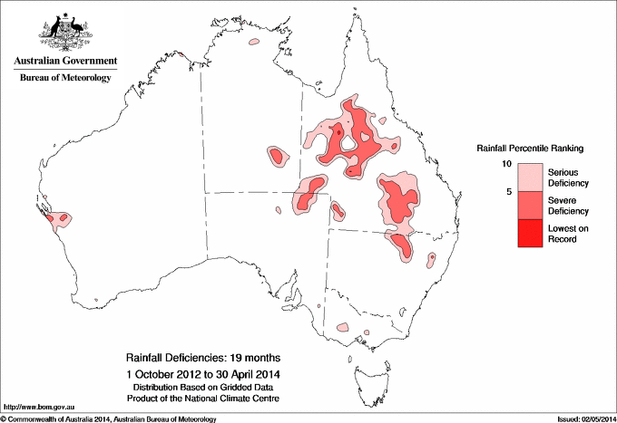

Queensland Government, Drought Declarations, http://www.longpaddock.qld.gov.au/queenslanddroughtmonitor/queenslanddroughtreport/index.php
Joint Media Release, Minister for Agriculture, Barnaby Joyce, and NSW Minister for Primary Industries, Katrina Hodgkinson, ‘More support for drought affected farmers in NSW’, 1 April 2014
Department of Agriculture, ABARES, Weekly Australian Climate, Water and Agricultural Update, 15 May 2014

