AMENDMENT | 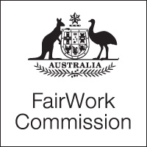

Notice of Listing

Title of Matter: | Annual Wage Review 2013-2014
Section: | s.285 - Annual wage review
Subject: | Final Consultations
Matter Number: | C2014/1

Hearing Details:
The above matter is listed for Hearing - Final Consultations, by Video link before the Expert Panel at:

10:00 am
Wednesday, 21 May 2014
Fair Work Commission
11 Exhibition Street
Melbourne
10:00 am
Wednesday, 21 May 2014
Fair Work Commission
Terrace Tower
80 William Street
East Sydney

10:00 am
Wednesday, 21 May 2014
Fair Work Commission
CML Building
17 - 21 University Avenue
Canberra
NOTE:
This notice has been amended to add an additional video link to Canberra for the Final Consultations on 21 May 2014.
The Expert Panel will be sitting in Sydney.

Inquiries: All inquiries relating to this notice are to be directed to David Mitchell
Phone: (03) 8661 7830, email: chambers.ross.j@fwc.gov.au, Fax: (03) 9655 0401.
Fair Work Commission, 20 May 2014 4:30 pm

