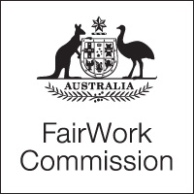

Notice of Listing

Title of Matter: | Annual Wage Review 2013-2014
Section: | s.285 - Annual wage review
Subject: | Decision
Matter Number: | C2014/1

Hearing Details:

The above matter is listed for Decision before the Expert Panel at:

2:00 pm
Wednesday, 4 June 2014
Fair Work Commission
11 Exhibition Street
Melbourne

NOTE:

The decision will be live-streamed on the Fair Work Commission website.

Inquiries: All inquiries relating to this notice are to be directed to David Mitchell
Phone: (03) 8661 7830, email: chambers.ross.j@fwc.gov.au, Fax: (03) 9655 0401.
Fair Work Commission, 3 June 2014 3:00 pm

