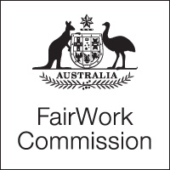

Notice of Listing

Title of Matter: | Annual Wage Review 2014–15
Section: | s.285 - Annual wage review
Subject: | Decision
Matter Number: | C2015/1

Hearing Details:
The above matter is listed for Decision before the Expert Panel at:

2:15pm
Tuesday, 2 June 2015
Fair Work Commission
11 Exhibition Street
Melbourne

NOTE:
The Expert Panel will be sitting in Melbourne
The Fair Work Commission will live stream the Decision.
To watch the hearing, please use the link that will be available on the home page of our website

Inquiries:
All inquiries relating to this notice are to be directed to Mirella Franceschini
Phone: (03) 8661 7829, email: chambers.ross.j@fwc.gov.au, Fax: (03) 9655 0401.
Fair Work Commission, 1 June 2015 4pm

