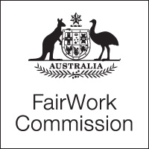

Notice of Listing

Title of Matter: | Annual Wage Review 2014–15
Section: | s.285 - Annual wage review
Subject: | Final Consultations
Matter Number: | C2015/1

Hearing Details:
The above matter is listed for Hearing - Final Consultations, by Video link before the Expert Panel at:

10:00 am
Tuesday, 19 May 2015
Fair Work Commission
11 Exhibition Street
Melbourne
10:00 am
Tuesday, 19 May 2015
Fair Work Commission
Terrace Tower
80 William Street
East Sydney

10:00 am
Wednesday, 20 May 2015
Fair Work Commission
11 Exhibition Street
Melbourne
10:00 am
Wednesday, 20 May 2015
Fair Work Commission
Terrace Tower
80 William Street
East Sydney

NOTE:
The Expert Panel will sit in Melbourne on 19 May and in Sydney on 20 May 2015.

Inquiries: All inquiries relating to this notice are to be directed to Annastasia Kyriakidis
Phone: (03) 8661 7830, email: chambers.ross.j@fwc.gov.au,
Fair Work Commission, 5 May 2015 10:00 am

