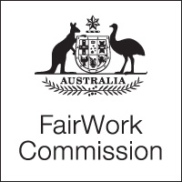

Notice of Listing

Title of Matter: | Annual Wage Review 2014-2015
Section: | s.285 - Annual wage review
Subject: | Public conference: medium-term research review
Matter Number: | C2015/1

Hearing Details:
The above matter is listed for Conference before the Expert Panel at:

11:00 am
Monday, 11 August 2014
Fair Work Commission
11 Exhibition Street
Melbourne

NOTE:
- The Expert Panel will be sitting in Melbourne.
- Any requests for video links should be sent to chambers.ross.j@fwc.gov.au by no later than 12pm Friday 8 August 2014.

Inquiries:
All inquiries relating to this notice are to be directed to Annastasia Kyriakidis
Phone: (03) 8661 7830, email: chambers.ross.j@fwc.gov.au, Fax: (03) 9655 0401.
Fair Work Commission, 31 July 2014

