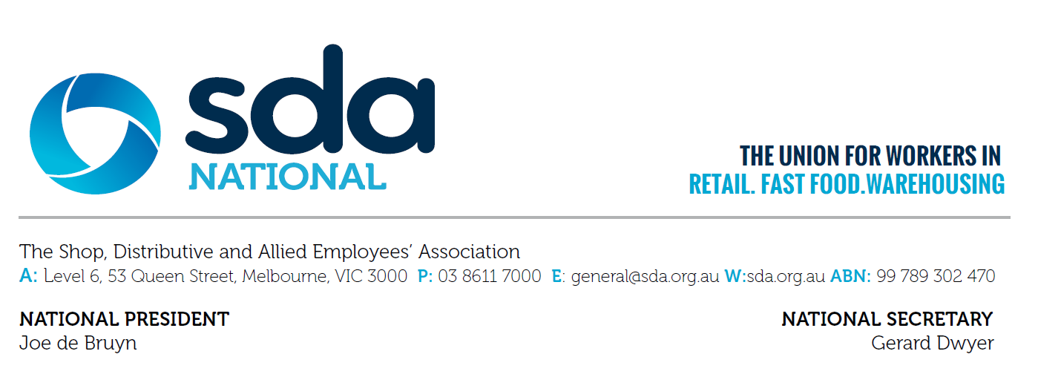
Annual Wage Review Panel
President Ross
Fair Work Commission
Level 4
11 Exhibition St,
Melbourne VIC 3000 8 May 2017
Via email: awr@fwc.gov.au ; chambers.ross.j@fwc.gov.au

Dear Associate,
Re Annual Wage Review 2016-2017

The SDA is withdrawing its submission dated 29th March 2017, from the Annual Wage Review 2016 – 2017.
We apologise to the Panel for any inconvenience this may have caused.

Yours sincerely,

Gerard Dwyer
National Secretary-Treasurer

