IN THE FAIR WORK COMMISSION
ANNUAL WAGE REVIEW 2019-2020
19 MARCH 2020

The Restaurant and Catering Industry Association
- Restaurant & Catering Industry Association (the “R&CA”) is pleased to provide a submission for the Annual Wage Review 2019-2020 (the “Review”). The R&CA is the national industry association representing the interests of more than 47,000 restaurants, cafés and catering businesses across Australia. The café, restaurant and catering sector is vitally important to the national economy, generating over $37 billion in retail turnover each year as well as employing 450,000 people.
- The R&CA delivers tangible outcomes to small businesses within the hospitality industry by influencing the policy decisions and regulations that impact the sector’s operating environment. The R&CA is committed to ensuring the industry is recognised as one of excellence, professionalism, profitability and sustainability. This includes advocating the broader social and economic contribution of the sector to industry and government stakeholders, as well as highlighting the value of the restaurant experience to the public.

The Industry and Employment
- Approximately 34% of small businesses rely on the minimum wage provided for by modern awards. Of this percentage, 92% of businesses in the café, restaurant and catering industry (the “industry operators”) are small businesses, employing 19 people or less.
- Figures from the Trends in Federal Enterprise Bargaining’ Report (September 2019 Quarter) prepared by the Federal Department of Jobs and Small Business reveal a growing pattern of Award coverage and a decline in Agreement coverage (refer to Figure 1). As such, a significant proportion of industry operators rely on the modern wage provided for by the modern awards.
- Industry operators continue to face ongoing challenges to their operating conditions. Specifically, as it was noted in the ‘Restaurants in Australia Industry Report’ prepared by IBISWorld (the “IBISWorld Report”), “Restaurants face[d] ongoing pressure to expand food choices on menus and increase customer satisfaction through a quicker turnaround, while preserving the taste and quality of food.”
- Given the small business arrangement for many industry operators, these challenges are further exacerbated by the limited support and financial assistance provided by the government.
- The restaurant industry also has a low capital intensity. It has been estimated that for every dollar a business spends on capital costs, $9.10 is spent on employees’ wages. As restaurants require a significant input of labour across all operations (including preparation, cooking, serving and cleaning), many industry operators have gone to the extent of leasing equipment (rather than investing in their own) in an effort to save costs.
- While it is anticipated that the restaurant industry would face a substantial increase in employment over the next three (3) year period (see Figure 2 below), the R&CA submits that any significant increase in employees’ wages will adversely affect the potential growth of an already economic sensitive industry.

Figure 1 – Award coverage vs Enterprise Agreement Coverage, 2010-2018
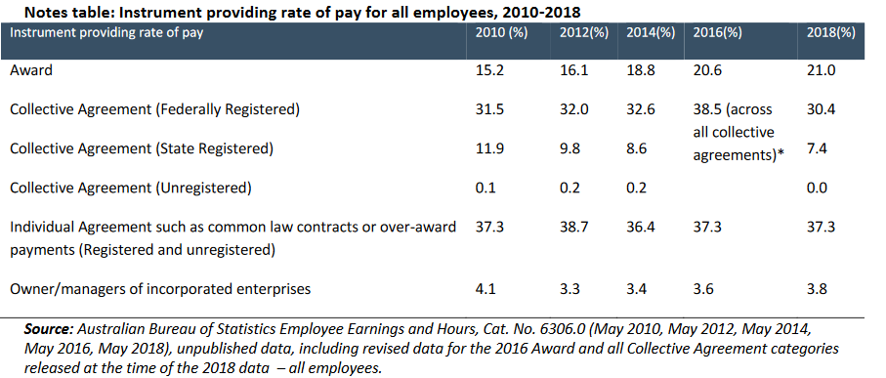

Figure 2 – Top Industry Sectors Ranked by Three (3) Years
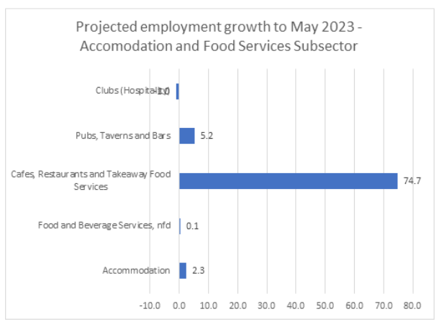

The 2019-2020 Annual Wage Review
- The R&CA welcomes the opportunity to provide a submission into the Review under section 289 of the Fair Work Act 2009 (the “Act”).
- Pursuant to section 285 of the Act, the Minimum Wage Panel (the “Panel”) is required to conduct an Annual Review of the national minimum wage order and the modern award minimum wages each financial year.
- When conducting the review, the Panel is required consider a number of economic and social factors as outlined in section 284(1) (the “minimum wages objective”) and section 134(1) (the “modern awards objective”).
- The minimum wages objective provides:
“284 The minimum wages objective
What is the minimum wages objective?
- The FWC must establish and maintain a safety net of fair minimum wages,
taking into account:
- the performance and competitiveness of the national economy, including
productivity, business competitiveness and viability, inflation and employment growth; and
- promoting social inclusion through increased workforce participation; and
- relative living standards and the needs of the low paid; and
- the principle of equal remuneration for work of equal or comparable value; and
- providing a comprehensive range of fair minimum wages to junior employees, employees to whom training arrangements apply and employees with a disability.
This is the minimum wages objective.
- The modern awards objectives provides:
“134 The modern awards objective
What is the modern awards objective?
- The FWC must ensure that modern awards, together with the National
Employment Standards, provide a fair and relevant minimum safety net of terms and conditions, taking into account:

- relative living standards and the needs of the low paid; and
- the need to encourage collective bargaining; and
- the need to promote social inclusion through increased workforce participation; and
- the need to promote flexible modern work practices and the efficient and productive performance of work; and
- the principle of equal remuneration for work of equal or comparable value; and
- the likely impact of any exercise of modern award powers on business, including on productivity, employment costs and the regulatory burden; and
- the need to ensure a simple, easy to understand, stable and sustainable modern award system for Australia that avoids unnecessary overlap of modern awards; and
- the likely impact of any exercise of modern award powers on employment growth, inflation and the sustainability, performance and competitiveness of the national economy.
This is the modern awards objective.”

Previous Annual Minimum Wage Decision
- The national minimum wage, at present, stands at $740.80 per week, or $19.49 per hour. All modern award minimum wages last year were increased by 3.0 percent following the Annual Wage Review 2018-19 Decision [2019] FWCFB 3500 (the “Review”).
- The R&CA had previously argued for a 0% increase in the Review based on the “cumulative effect of the last four years’ minimum wage increases and the prevailing economic conditions.”

Junior Employees
- In the Review, the Panel considered junior rates of pay in modern awards.
- The R&CA supports a proportionate flowing on of any review decision to junior rates of pay.
- The R&CA may provide a response in its reply submissions where any matters arise.

Apprentices and Trainees
- The R&CA notes that while experience and training are desirable and may assist in profitability for industry operators, there are no formal qualifications necessary for operators to effectively operate in the industry. Other factors such as marketing and social media are equally important in driving profitability.
- On these bases, the R&CA supports the proportionate flow on of any review decision to modern award minimum wages for employees to whom training arrangements apply under the relevant awards.

Casual Loadings
- The R&CA notes that it is likely that restaurant industry will continue to move towards casualisation as the desire grows for flexibility continues to grow.
- Despite some concern as to instability resulting from the casualisation of the workforce, R&CA submits that this instability is compensated by the recent casual conversion provisions which have been inserted into many modern awards, together with a greater emphasis on training and development of current staff.
- As such, it is the R&CA’s view that the standard casual loading in modern awards as well as Award and Agreement free employees be maintained at 25%.

The Performance of the Australian Economy
- The R&CA notes that GDP grew by 1.9% in 2018-19, with a forecast of 2.25% in 2019-20 and 2.75% in 2020-21. A comparative analysis reveals that Australia’s growth is generally good when compared to other OECD economies.
- However, the R&CA recognises the detrimental impacts on the Australian economy, including industry operators, as a result of the recent Australian bushfires and the ongoing challenges arising from the COVID-19 (the “Coronavirus”).
- The R&CA supports the federal government’s response to these events, in particular the $17.6 billion dollar stimulus package in response to the Coronavirus providing relief for cash payments and tax relief for small businesses, as well as state government initiatives.
- It is the R&CA’s view that the Australian economy is likely to experience a very weak first half of 2020. It is also uncertain at this stage as to whether global growth together with monetary and fiscal stimulus will take effect by the latter half of 2020.

Considerations Specific to the Industry
- Figures from the R&CI Industry Benchmarking Report 2019 (the “Report”) revealed that the cost of wages averaged 41% of total business costs, with more than 50% of total business costs relating to staff. This figure had increased from 39.6% as was recorded in the 2016-2017 Report, and 37% in the 2015-2016 Report.
- More recently, industry operators have financially struggled due to the emergence and significant growth of online food delivery platforms within the market. Figures from the Report revealed that 55.5% of the 656 respondents surveyed stated that the fees associated with online food delivery were too high, and that it was impossible to make a profit using online food delivery platforms.
- The R&CA respectfully requests that the Panel take into consideration the above key considerations when arriving at their final determination.

The R&CA’s Position
- With consideration to all the above, the R&CA advocates for a 12 month freeze to any changes to the modern award wages and the National Minimum Wage.
- It is the R&CA’s view that it would be unreasonable, in the current circumstances, for the modern award wages and the National Minimum Wage to be increased which would adversely affecting small and medium sized businesses in the current climate.

We thank the Government for considering our submission. If you wish to discuss R&CA’s views further, do not hesitate to contact Victor Song (Senior Adviser – Industrial Relations and Policy) by email on victors@restaurantcater.asn.au.

We thank you again for the opportunity to make this submission.
Regards
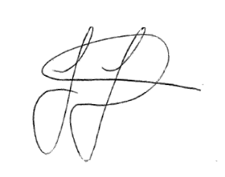
Wes Lambert CPA FGIA MAICD
Chief Executive Officer
Restaurant and Catering Australia

Compares the amount of money spent on capital (e.g., machinery and equipment) with that spent on labour.

